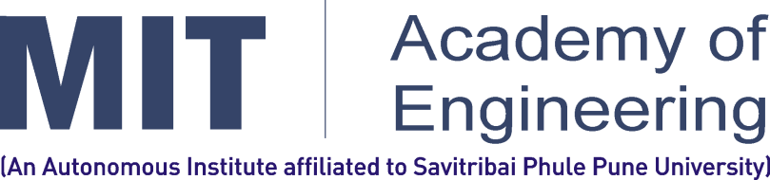

**Pune - 412105, Maharashtra (India)**

**2018-19**

**REDX**

**REPORT OF WEEK 2**

**Submitted by**

Team Name: Alphadroids

**IDEA 1: Parking Management**

As more number of people will be visiting the temple by vehicles such as in buses, trucks and cars so it will be problem for them to where park their vehicles and this will also cause traffic , so we came up with an idea in which we use image processing in ai which tells about is there any space remaining or not and if some space is available then is it sufficient for car or for a bus . We will do it by placing camera at a defined altitude so that it can process the vehicles and tell for the vacant places.

**IDEA 2: Clean Water AI**

In this project AI can be used to detect harmful bacteria with help of IOT and we will focus on **Supervised Learning**. This project will meticulously check the quality of water. Due to predictive analysis we came to know visitors were querulous for the quality of water.

**IDEA 3: Accommodation for Visitors**

As Wari is a 3 – 4 day program so it requires a stay for visitors and staying at hotels will be very expensive for them. So, we will talk to the nearby residents, if they voluntarily give their rooms for stay and we will display number of rooms available and display on monitors in Marathi, English, Hindi. We can build a chatbot service for the visitors. From the previous data we can do prediction analysis about the availability of rooms.

**Meeting:**

